**IS 143-DISCRETE STRUCTURES**

**ASSIGNMENT 1**

**2.** Given A =Ø , B= Ø Required To prove that A×B=Ø

This implies its required show that A×B󠇉⊆Ø and also Ø⊆A×B

Case 01

for A×B󠇉⊆Ø

Procedures Reasons

Let( x,y) ∊ A×B󠇉.

x∊A and y∊B definition of Cartesian product of two sets

x∊ Ø and y∊ Ø from hypothesis A= Ø and B= Ø

(x,y) ∊( Ø× Ø) definition of Cartesian product of two sets

(x,y) ∊ Ø

(x,y) ∊ A×B󠇉 ⇒ (x,y) ∊ Ø

∴A×B󠇉⊆Ø

And Conversely also to show that

Case 02

Ø⊆A×B

Procedures Reasons

let(x,y) ∊ Ø

(x,y) ∊( Ø× Ø)

x∊ Ø and y∊ Ø definition of Cartesian product of two sets

x∊A and y∊B from the hypothesis A= Ø and B= Ø

( x,y) ∊ A×B󠇉 Definition of Cartesian product of two sets

(x, y) ∊ Ø⇒(x, y) ∊ A × B󠇉

∴Ø⊆A×B

Since A×B󠇉⊆Ø and Ø⊆A×B, Then A×B=Ø

4. Since A = {a,b}, B{ 2,3} and C{ 3,4}

(1) Required to find A×(B∪C), (A×B) ∪ (A×C) and to show that A×(B∪C)= (A×B) ∪ (A×C)

Now

B∪C= {2, 3, 4}

⇒ A×( B∪C)={(a,2), (a,3), (a,4) (b,2), (b,3), (b,4)}

∴ A×( B∪C)={(a,2), (a,3), (a,4) (b,2), (b,3), (b,4)}

Again

A×B={(a,2), (a,3), (b,2), (b,3)} and A×C={(a,3), (a,4), (b,3), (b,4)}

⇒ (A×B) ∪ (A×C)= {(a,2), (a,3), (a,4) (b,2), (b,3), (b,4)}

∴ (A×B) ∪ (A×C)= {(a,2), (a,3), (a,4) (b,2), (b,3), (b,4)}

Now, To show that A×(B∪C)= (A×B) ∪ (A×C)

i.e. A×(B∪C) ⊆ (A×B) ∪ (A×C) and (A×B) ∪ (A×C) ⊆A×(B∪C)

Consider for A×(B∪C) ⊆ (A×B) ∪ (A×C)

Procedures Reason

Let (x,y)∈ A×(B∪C)

⇒ x∈A and y∈(B∪C) Definition of Cartesian product of two sets

⇒ x∈A and( y∈B or y∈C) Definition of Union of Two sets

⇒ (x∈A and y∈B) or (x∈A and y∈C) Distributive property of sets

⇒(x,y)∈ (A×B) or (x,y)∈ (A×C) Definition of Cartesian product of two sets

⇒(x,y)∈ (A×B) ∪ (A×C) Definition of Union of Two sets

(x,y)∈A×(B∪C) ⇒ (x,y)∈(A×B) ∪ (A×C)

∴A×(B∪C) ⊆ (A×B) ∪ (A×C)

Conversely To show that (A×B) ∪ (A×C) ⊆A× (B∪C)

Procedures Reason

let (x,y)∈ (A×B) ∪ (A×C)

⇒(x,y)∈ (A×B) ∪ (x,y)∈ (A×C) Distributive property of sets

⇒(x,y)∈ (A×B) or (x,y)∈ (A×C) Definition of Union of sets

⇒ (x∈A and y∈B) or (x∈A and y∈C) Definition of Cartesian product of two sets

⇒ x∈A and( y∈B or y∈C) Distributive property of sets

⇒ x∈A and y∈(B∪C) Definition of Union of sets

⇒ (x,y)∈ A×(B∪C) Definition of Cartesian product of two sets

∴( A×B) ∪ (A×C) ⊆ A×(B∪C)

Since A×(B∪C) ⊆ (A×B) ∪ (A×C) and ( A×B) ∪ (A×C) ⊆ A×(B∪C)

Then A×(B∪C)= (A×B) ∪ (A×C)

(2) Required to show that A×(B ∩ C)= (A×B) ∩ (A×C)

i.e. A×(B ∩ C) ⊆ (A×B) ∩ (A×C) and (A×B) ∩ (A×C) ⊆A×(B ∩ C)

Consider for A×(B∩C) ⊆ (A×B) ∩ (A×C)

Procedures Reason

Let (x,y)∈ A×(B ∩ C)

⇒ x∈A and y∈(B ∩ C) Definition of Cartesian product of two sets

⇒ x∈A and( y∈B and y∈C) Definition of intersection of Two sets

⇒ (x∈A and x∈A) and (x∈B and y∈C) Idempotent property of sets

⇒(x,y)∈ (A×B) and (x,y)∈ (A×C) Definition of Cartesian product of two sets

⇒(x,y)∈ (A×B) ∩ (A×C) Definition of intersection of Two sets

(x,y)∈ A×(B ∩ C) ⇒ (x,y)∈ (A×B) ∩ (A×C)

∴A×(BC) ⊆ (A×B) ∪ (A×C)

Conversely To show that (A×B) ∪ (A×C) ⊆A×(B∪C)

Procedures Reason

Let (x,y)∈ (A×B) ∩ (A×C)

⇒(x,y)∈ (A×B) ∩ (x,y)∈ (A×C) Distributive property of sets

⇒(x,y)∈ (A×B) and (x,y)∈ (A×C) Definition of intersection of sets

⇒ (x∈A and y∈B) and (x∈A and y∈C) Definition of Cartesian product of two sets

⇒(x∈A and y∈A) and ( y∈B and y∈C) Distributive property of sets

⇒ x∈A and y∈(B∩C) Idempotent property of sets

⇒ (x,y)∈ A×(B∩C) Definition of Cartesian product of two sets

∴ ( A×B) ∩ (A×C) ⊆ A×(B∩C)

Since A×(B∩C) ⊆ (A×B) ∩ (A×C) and ( A×B) ∩ (A×C) ⊆ A×(B∩C)

Then A×(B∩C)= (A×B) ∩ (A×C)

7. Required to Show That A∩(B⊕C)=(A∩B) ⊕ (A∩C) if A, B and C are Any sets

i.e. A∩(B⊕C) ⊆ (A∩B) ⊕ (A∩C) and (A∩B) ⊕ (A∩C) ⊆ A∩(B⊕C)

Now to show that A∩(B⊕C) ⊆ (A∩B) ⊕ (A∩C)

Procedures Reason

Let x∈ A∩(B⊕C)

⇒x∈ A and x∈(B⊕C) Definition of intersection of sets

⇒( x∈ A and ( x∈ A ⊕ x∈C) Distributive property of sets

⇒( x∈ A and x∈B)⊕( x∈ A and x∈C) Distributive property of sets

⇒( x∈ A∩B)⊕( x∈ A∩C) Definition of intersection of sets

⇒ x∈( A∩B)⊕ (A∩C) Distributive property of sets

∴A∩(B⊕C) ⊆ (A∩B) ⊕ (A∩C)

Conversely to show that (A∩B) ⊕ (A∩C) ⊆ A∩(B⊕C)

Procedures Reason

Let x∈( A∩B)⊕ (A∩C)

⇒ ( x∈ A∩B)⊕( x∈ A∩C) Distributive property of sets

⇒ ( x∈ A and x∈B)⊕( x∈ A and x∈C) Definition of intersection of sets

⇒ ( x∈ A and ( x∈ A ⊕ x∈C) Distributive property of sets

⇒x∈ A and x∈(B⊕C) Distributive property of sets

⇒x∈ A∩(B⊕C) Definition of intersection of sets

∴ (A∩B) ⊕ (A∩C) ⊆ A∩(B⊕C)

Since A∩(B⊕C) ⊆ (A∩B) ⊕ (A∩C) and (A∩B) ⊕ (A∩C) ⊆ A∩(B⊕C)

Then A∩(B⊕C)=(A∩B) ⊕ (A∩C)

8. Required to show that A∪(B-A)=B if A⊂B

i.e. A∪(B-A) ⊆B and B⊆ A∪(B-A)

Now, to show that A∪(B-A) ⊆B

Procedures Reason

Let x∈ A∪(B-A)

⇒ x∈ A or x∈ (B-A) Definition of union of sets

⇒ x∈ A or x∈ B ∩ A’ Definition of difference of two sets

⇒ x∈ A or( x∈ B and x∈ A’) Definition of intersection of sets

⇒ (x∈ A or x∈ B) and (x∈ A or x∈ A’) Distributive property of sets

⇒ (x∈ A ∪ B) and (x∈ A ∪ A’) Definition of union of sets

⇒ (x∈ A ∪ B) and x∈µ Complement law of sets

⇒ x∈ B and x∈µ From hypothesis A⊂B

⇒ x∈ B∩µ Definition of intersection of sets

⇒ x∈ B Identity property of sets

∴ A∪(B-A) ⊆B

Conversely to show that B⊆ A∪(B-A)

Procedures Reason

Let x∈ B

⇒ x∈ B∩µ Identity property of sets

⇒ x∈ B and x∈µ definition of intersection of sets

⇒ (x∈ A ∪ B) and x∈µ From hypothesis A⊂B

⇒ (x∈ A ∪ B) and (x∈ A ∪ A’) Complement law of sets

⇒ (x∈ A or x∈ B) and (x∈ A or x∈ A’) Definition of union of sets

⇒ x∈ A or( x∈ B and x∈ A’) Distributive property of sets

⇒ x∈ A or x∈ B ∩ A’ Definition of intersection of sets

⇒ x∈ A or x∈ (B-A) Definition of difference of two sets

⇒x∈ A∪(B-A) Definition of union of two sets

∴B⊆ A∪(B-A)

Since A∪(B-A) ⊆B and B⊆ A∪(B-A)

Then A∪(B-A)=B

25.

Let µ represent the universal set=500 people.

F for football game=285 people.

H for hockey game = 195 people.

B for basketball game= 115 people.

F ∩ B = 45 people.

F ∩ H = 70 people.

H ∩ B = 50 people.

Ø= 50 people

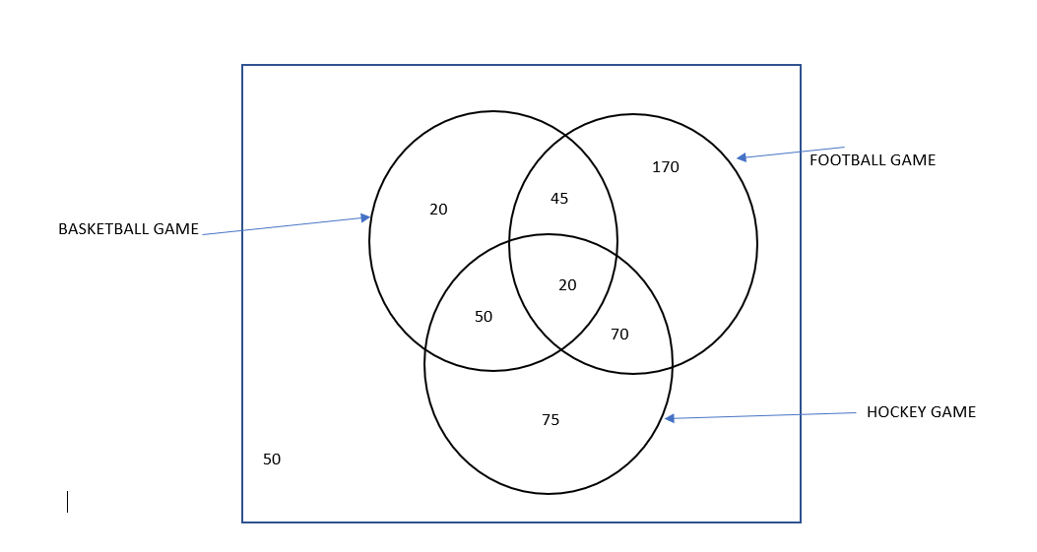

26.

Let F be the number of faculty members who speak French = 200

R be the number of faculty members who speak Russian =50

S be the number of faculty members who speak Spanish = 100

F ∩ R= 20

F ∩ S = 60

R ∩ S = 35

R ∩ S ∩ F = 10

